**Name: Daylen Mackey**

We have a team selected: Leo Marroquin, Jia Xiang (Tony) Yang, and Ian Then

**Favorite Engineering Topic:**

Embedded Design! I really enjoy programming, so I absolutely love when I get to combine hardware with low level code!

**Special Engineering or Business Talent:**

I’m a relatively experienced web developer who’s familiar with using Python for data analysis. I have also helped file patents.

**Proudest Engineering or Personal Achievement:**

My personal portfolio website

At this point, all my experience with web development had been somewhat confined – I would complete tasks that were integrated into a larger site, or build sites using Wordpress and Shopify. Building a website from scratch was far more challenging, but allowed me to apply all my knowledge on the matter.

**Work Experience:**

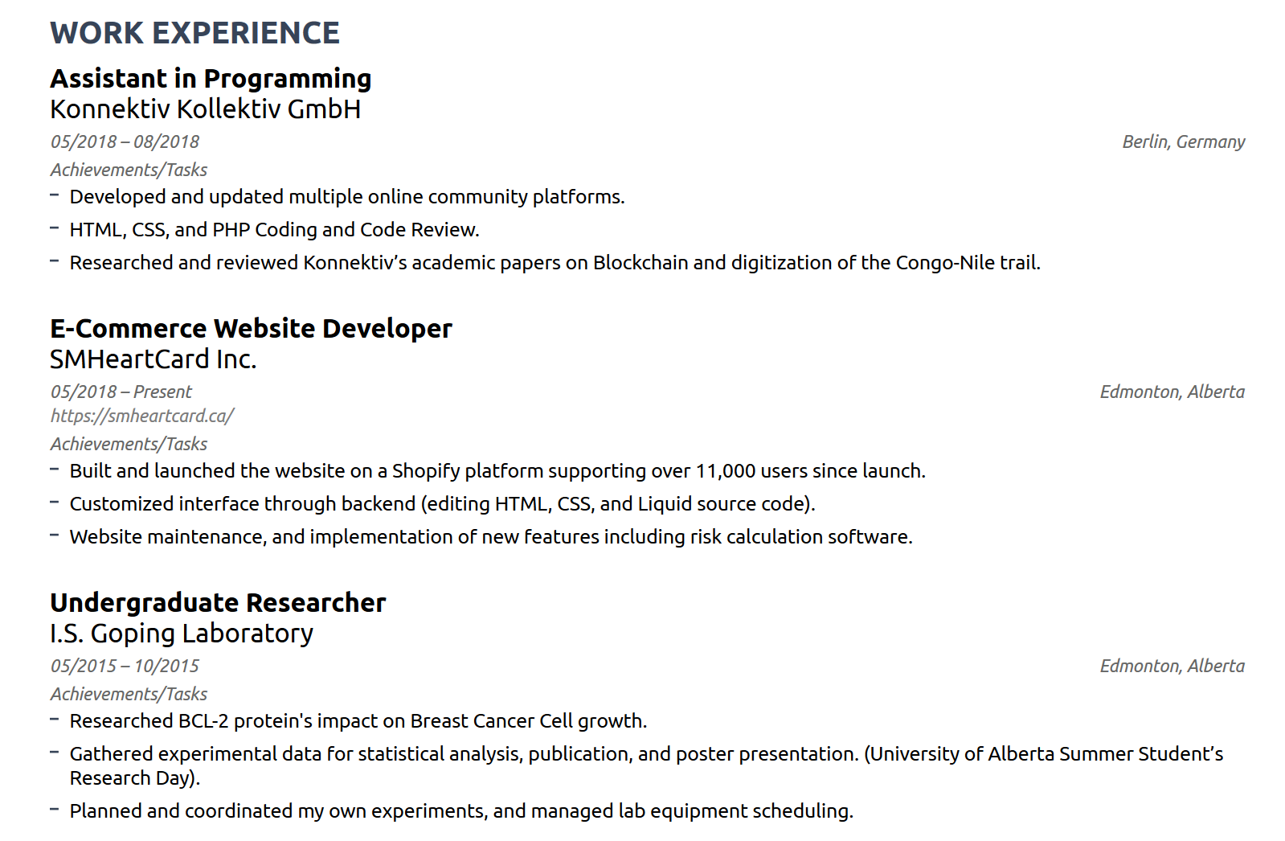

(Screenshotted to preserve formatting)

**Strengths:**

* **Programming**: Python, C, Javascript, HTML, CSS, MATLAB, Swift
* **Data Science**: Numpy, Pandas, Matplotlib, IBM Cloud and IBM Watson

**What skills do you want to develop this term:** I would really like to learn more about PCB design. My partner Leo has experience with PCBs, so I plan on scraping as much knowledge from his as possible.

**Results of the skills assessment:** 